JENKINS installation on EC2 instance.

1. Create one AWS EC2 instance
2. Install Git, Maven, Java, Jenkins
3. Create AWS EC2 instance

Login on AWS with your account

Goto EC2 service

Click on Launch instance

Give any name

Select Amazon Linux server

Select AMI : Amazon Linux 2023 AMI free service

Select Instant type: t2 micro

Select existing key pair if present

Select create new security group

Keep other parameters as it is.

Click on Launch instance 🡪 Once services get started, we need to change inbound rule.

Click Security 🡪 click on Security Rule 🡪 Click on Edit Inbound Rule 🡪 click Add Rule

1. Installation of Git, JAVA MAVEN and Jenkins

Take public IP of newly created server from AWS console

Open Putty

Paste public in terminal, provide private key as well

Login on server with user : ec2-user

We need execute below commands to install the packages.

1. Git Installation

Fire below commands

yum -y update

yum install -y git

After execution of above command, we can see below status and can see version of Git with git –version command.

Installed:

git-2.40.1-1.amzn2023.0.3.x86_64 git-core-2.40.1-1.amzn2023.0.3.x86_64 git-core-doc-2.40.1-1.amzn2023.0.3.noarch perl-Error-1:0.17029-5.amzn2023.0.2.noarch

perl-File-Find-1.37-477.amzn2023.0.6.noarch perl-Git-2.40.1-1.amzn2023.0.3.noarch perl-TermReadKey-2.38-9.amzn2023.0.2.x86_64 perl-lib-0.65-477.amzn2023.0.6.x86_64

Complete!

[root@ip-172-31-15-91 ~]# git --version

**git version 2.40.1**

[root@ip-172-31-15-91 ~]#

1. JAVA installation

yum install -y java-21-amazon-corretto

yum install -y java-21-amazon-corretto-devel

After execution of above command we can see below status and we can check version as well with java –version command.

Installed:

java-21-amazon-corretto-devel-1:21.0.5+11-1.amzn2023.1.x86_64

Complete!

[root@ip-172-31-15-91 ~]# java --version

openjdk 21.0.5 2024-10-15 LTS

OpenJDK Runtime Environment Corretto-21.0.5.11.1 (build 21.0.5+11-LTS)

OpenJDK 64-Bit Server VM Corretto-21.0.5.11.1 (build 21.0.5+11-LTS, mixed mode, sharing)

[root@ip-172-31-15-91 ~]#

[root@ip-172-31-15-91 ~]# which java

/usr/bin/java

[root@ip-172-31-15-91 ~]# readlink -f /usr/bin/java

**/usr/lib/jvm/java-21-amazon-corretto.x86_64/bin/java**

[root@ip-172-31-15-91 ~]#

1. MAVEN installation

cd /opt

sudo wget https://dlcdn.apache.org/maven/maven-3/3.9.9/binaries/apache-maven-3.9.9-bin.tar.gz

sudo tar xvf apache-maven-3.9.9-bin.tar.gz

ls -ltr

cd

echo "export M2_HOME=/opt/apache-maven-3.9.9" >> .bash_profile

echo "export M2=$M2_HOME/bin" >> .bash_profile

echo "export PATH=$M2:$PATH" >> .bash_profile

source ~/.bash_profile

echo $M2_HOME

[root@ip-172-31-15-91 ~]# echo $M2_HOME

/opt/apache-maven-3.9.9

[root@ip-172-31-15-91 ~]#

1. Jenkins Installation

sudo wget -O /etc/yum.repos.d/jenkins.repo \

https://pkg.jenkins.io/redhat-stable/jenkins.repo

sudo rpm --import https://pkg.jenkins.io/redhat-stable/jenkins.io-2023.key

sudo yum upgrade

sudo yum install -y jenkins

sudo systemctl daemon-reload

service jenkins start 🡪 to start the services

chkconfig jenkins on

1. Complete setup on Jenkins through UI

Open UI 🡪 3.109.200.0:8080 🡪

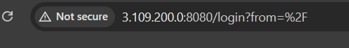

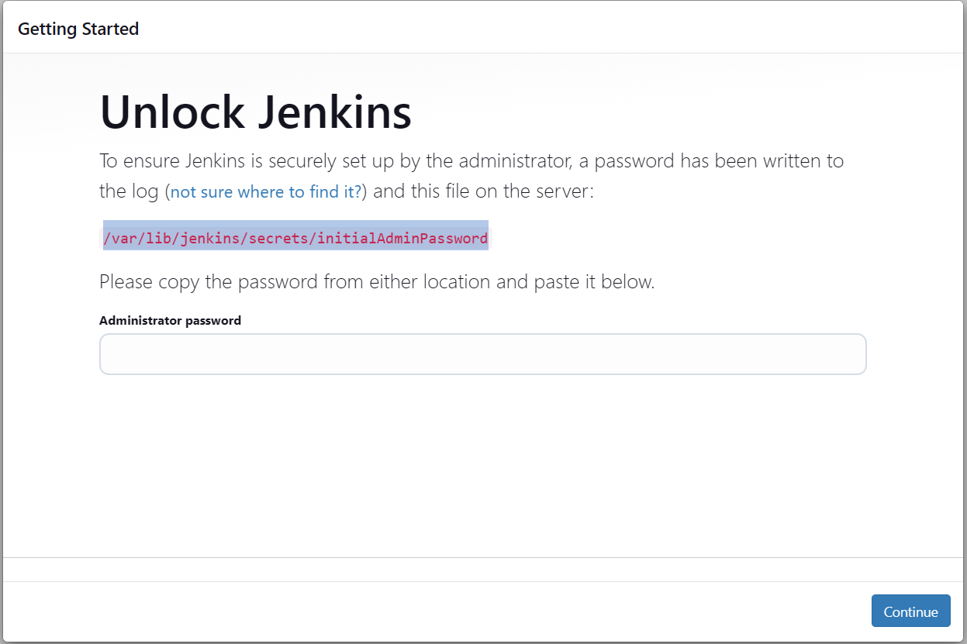

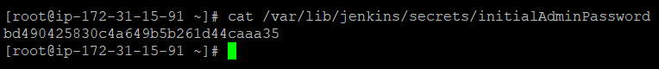

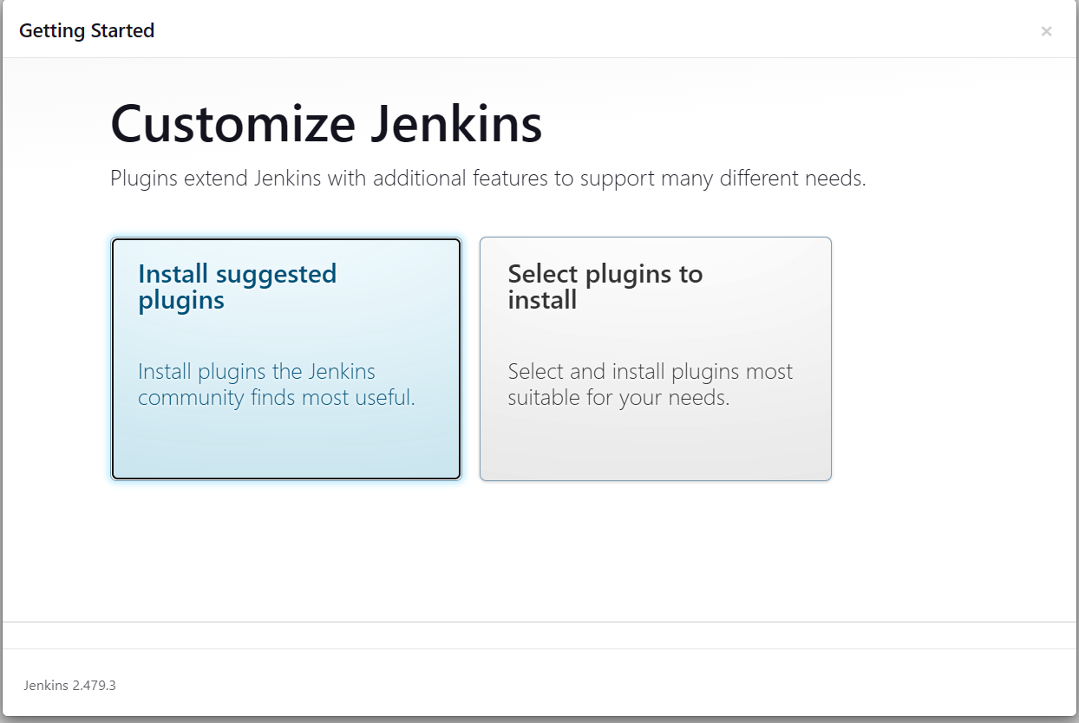

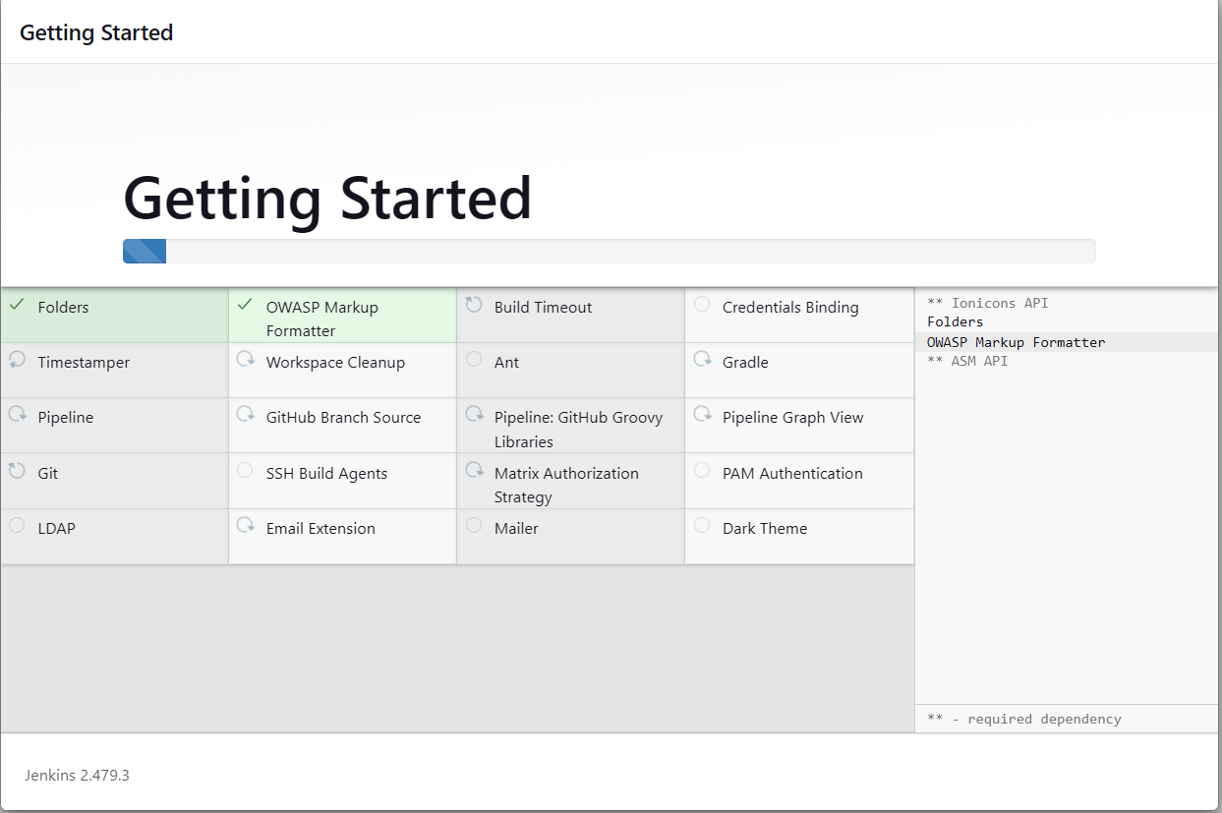

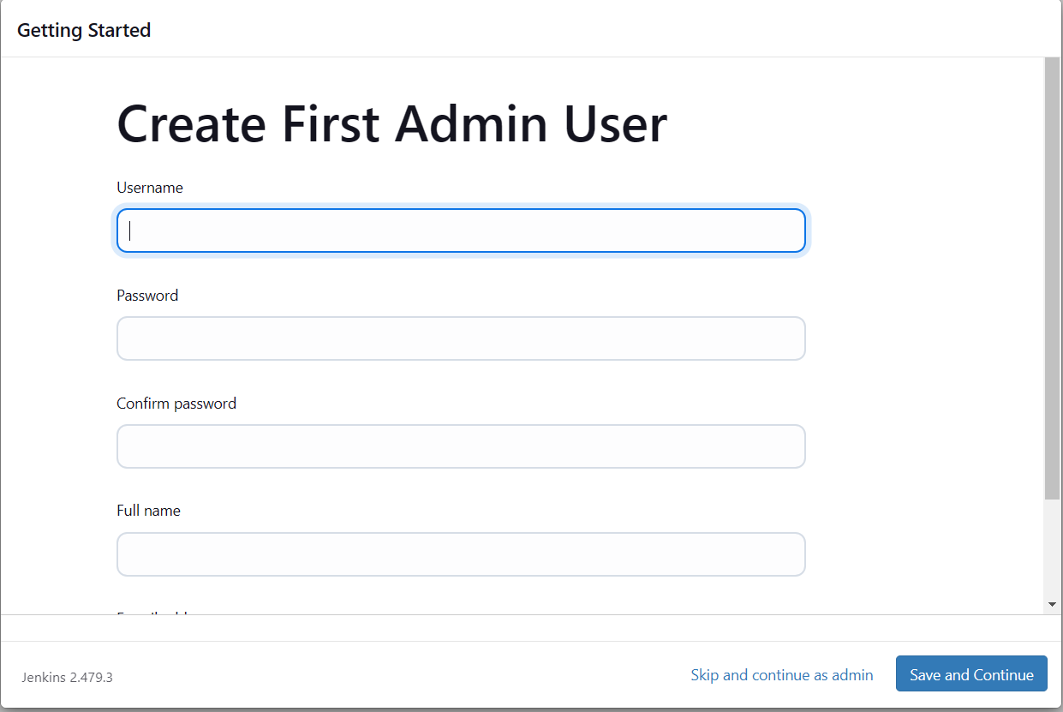

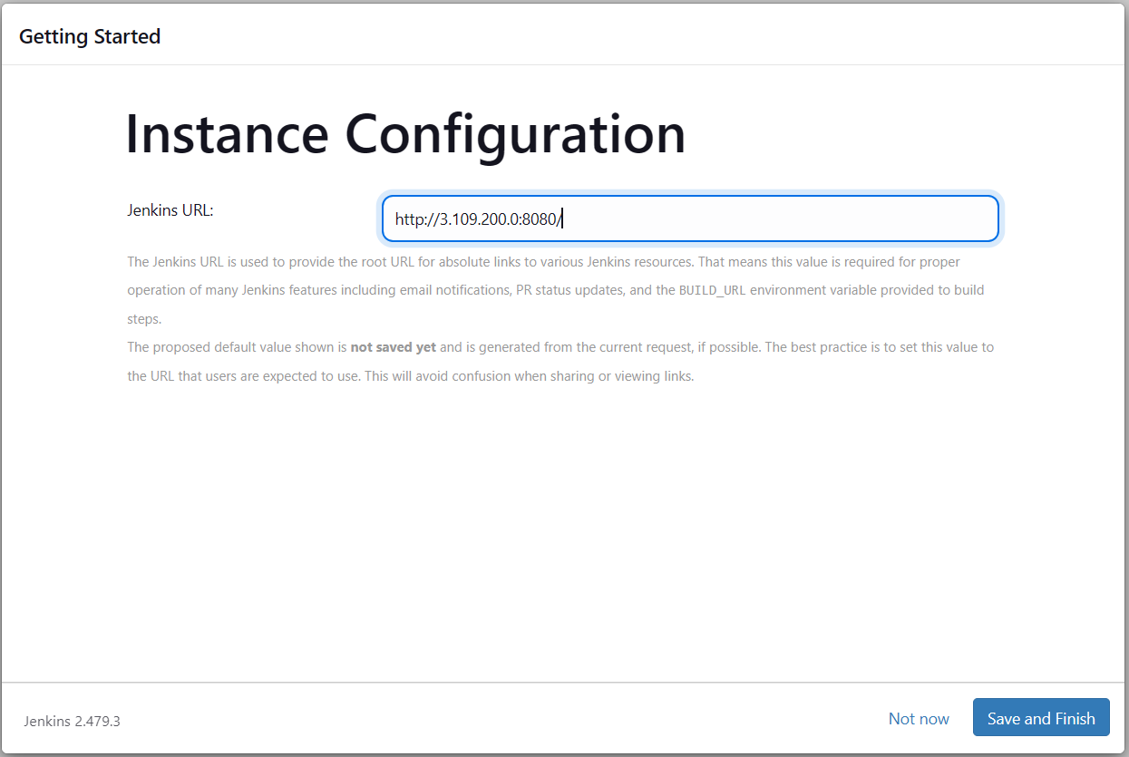

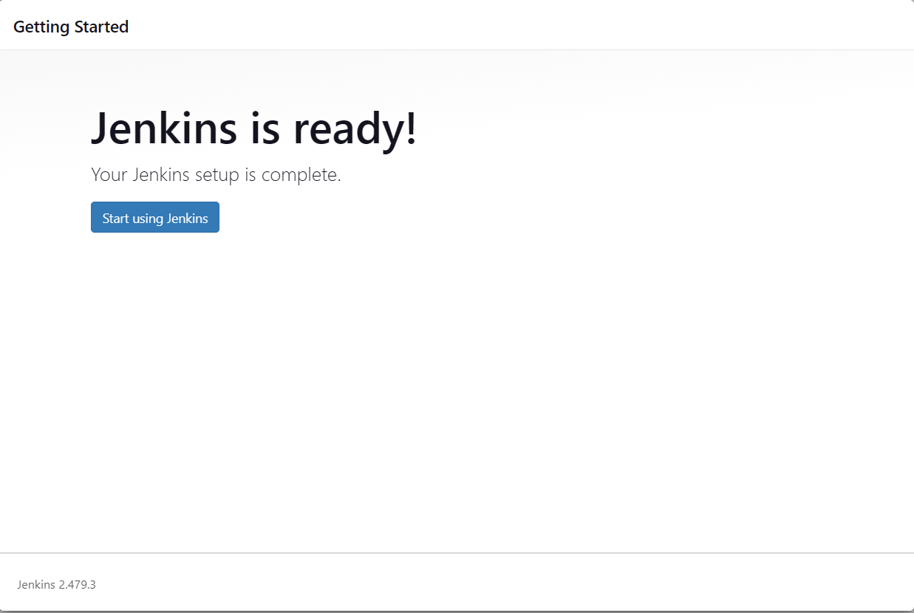

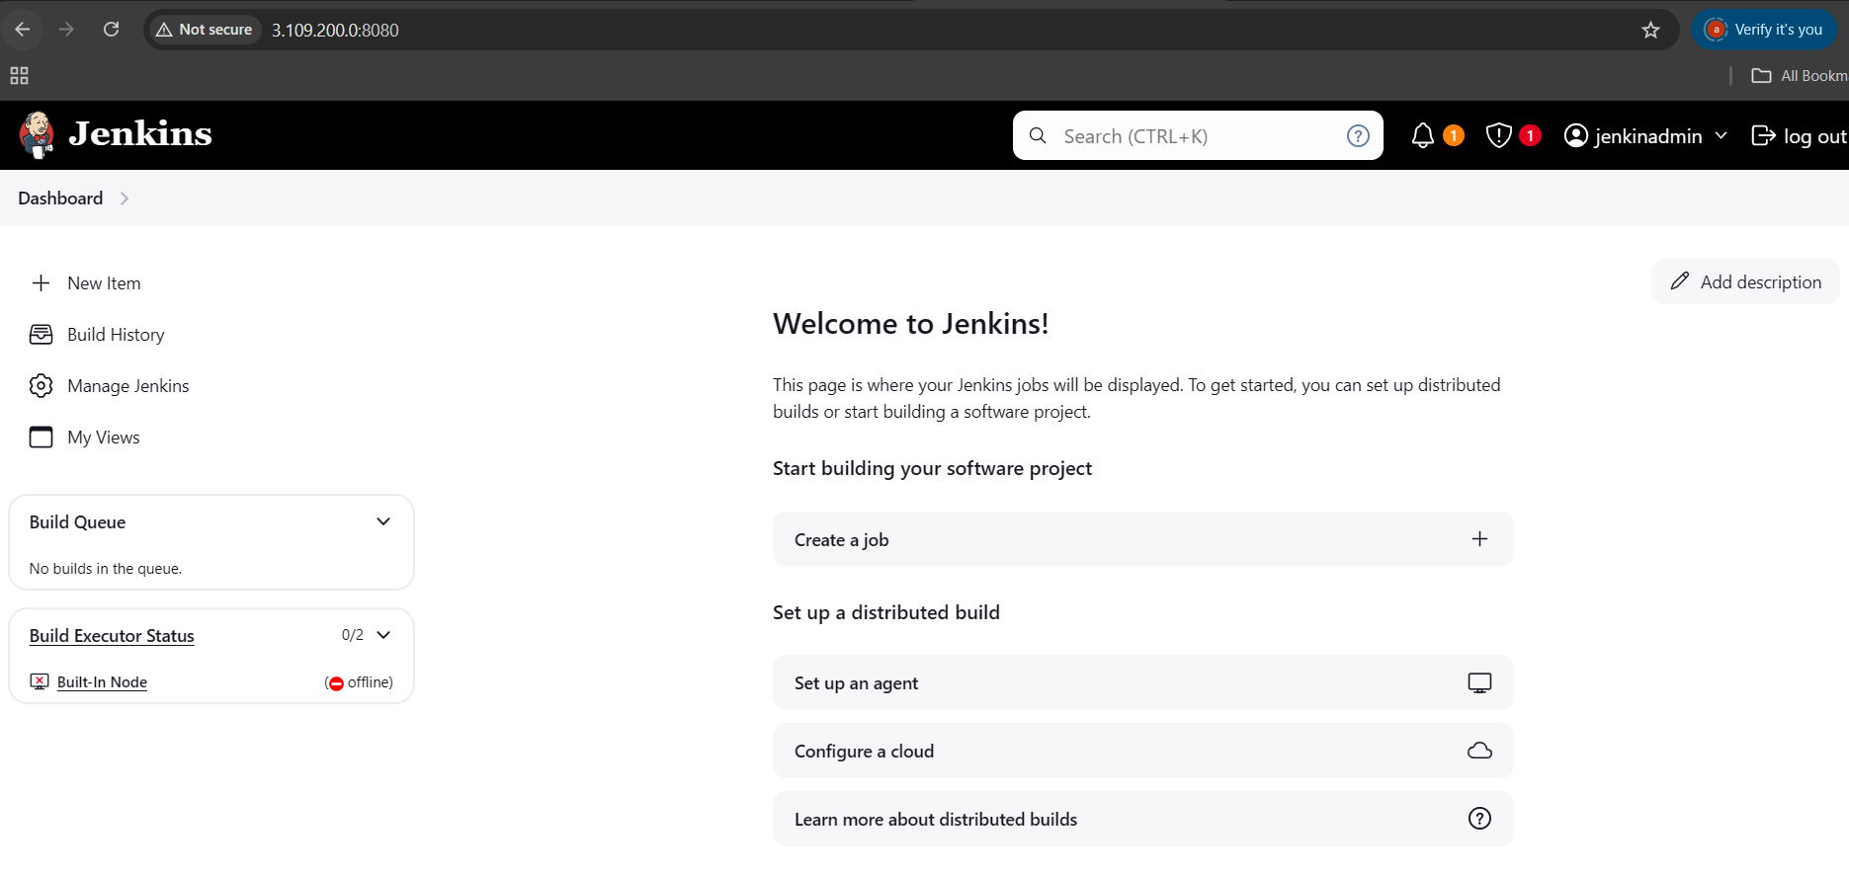

Once JENKINS get started, we need to configure GIT, MAVEN and JAVA JDK path in Jenkins.

Click on Manage Jenkins 🡪 Tools

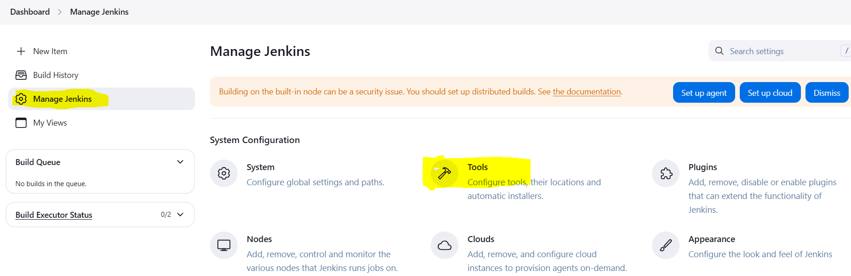

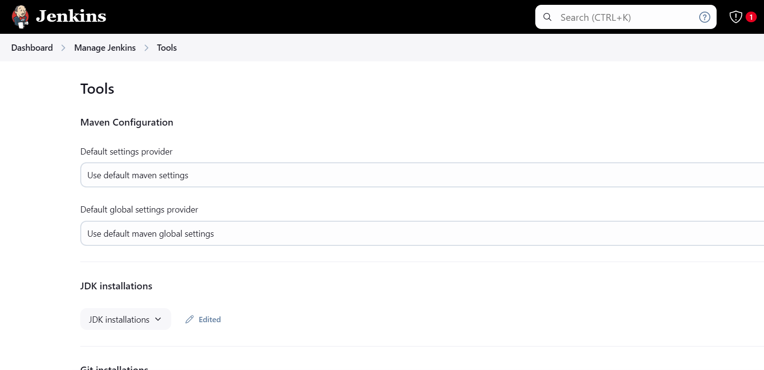

Go down and check for JDK Installations.

Take path from server where we installed JAVA.

Which java

Readlink -f /usr/bin/java

/usr/lib/jvm/java-21-amazon-corretto.x86_64/

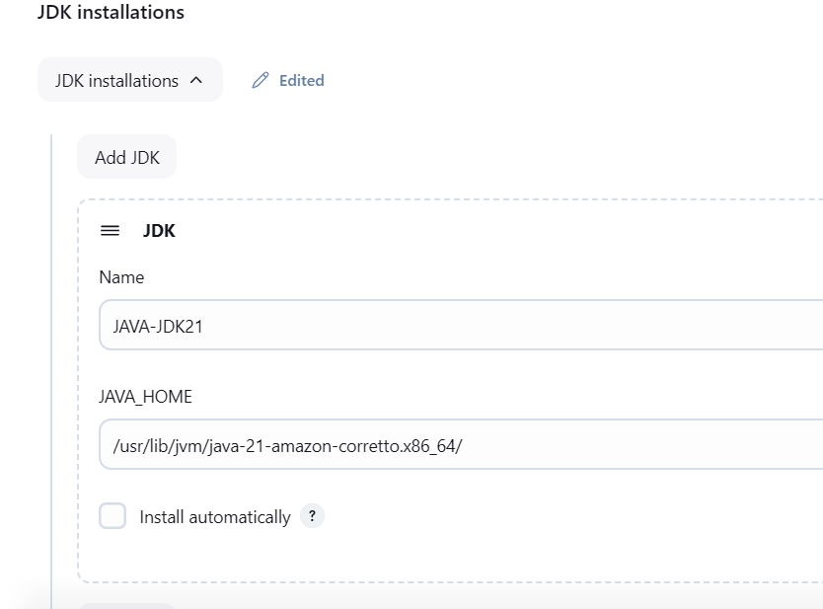

1. Check for Git and take path from server 🡪 to find path use this command 🡪 which git

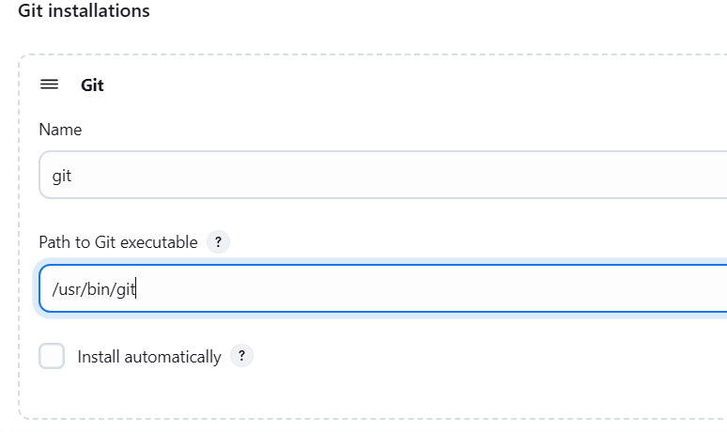

1. MAVEN path setup

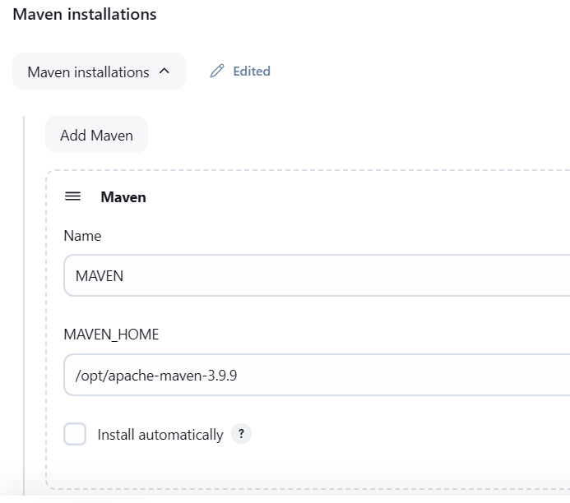

And click on SAVE button to save the changes….